**LAB: 03**

**Document Object Model [DOM]**

**Objective:**

To learn what is DOM and the APIs available for manipulating them.

**Lab Task:**

Create a new Student Profile page a. Add Title using suitable h1 or h2 tag b. Add an introduction paragraph along with image using p and img tags respectively c. Add a table listing down courses taken using table tag i. Add course Id, course Name, credit hours and year taken in ii. Add at least four courses using row tag iii. At the bottom of table, create a div tag and add following buttons 1. Add new Course 2. Update Course 3. Remove Course iv. Add a new button alongside other buttons under the table called Remove All New for removing all the newly created courses (rows). Perform DOM manipulation using different APIs: document.querySelector, document.querySelectorAll, addEventListener, etc.

**Coding:**

**Output:**

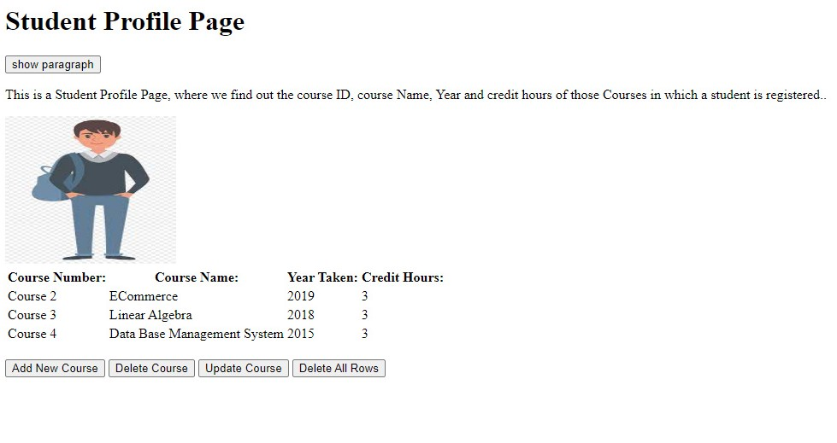

**Home Task:**

Create a Student Registration form and perform DOM validation using document.form DOM API. i. If any form field is empty, generate an alert message, and returns false, to prevent the form from being submitted. ii. Set HTML styles using DOM..

**Coding;**

**Output:**

